In a garden represented as an infinite 2D grid, there is an apple tree planted at **every** integer coordinate. The apple tree planted at an integer coordinate (i, j) has |i| + |j| apples growing on it.

You will buy an axis-aligned **square plot** of land that is centered at (0, 0).

Given an integer neededApples, return *the****minimum perimeter****of a plot such that****at least***neededApples *apples are****inside or on****the perimeter of that plot*.

The value of |x| is defined as:

* x if x >= 0
* -x if x < 0

**Example 1:**

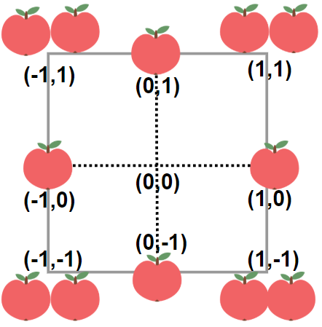

**Input:** neededApples = 1

**Output:** 8

**Explanation:** A square plot of side length 1 does not contain any apples.

However, a square plot of side length 2 has 12 apples inside (as depicted in the image above).

The perimeter is 2 * 4 = 8.

**Example 2:**

**Input:** neededApples = 13

**Output:** 16

**Example 3:**

**Input:** neededApples = 1000000000

**Output:** 5040

**Constraints:**

* 1 <= neededApples <= 1015